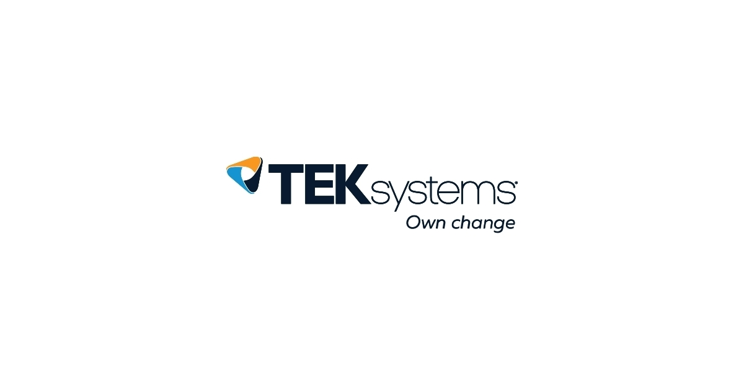

**Project Understanding Document**

# Project Vision/Overview

EAS aims to automate the enrollment process of an employee after he/she is selected through the recruitment process and decides to accept the offer provided by the company. The System intends to automate the manual process of enrollment of an employee, which consumes a lot of time and manual enrollments can often lead to errors. This System would help in saving time and efforts of both HR and the Employee being enrolled. The system will become active as soon as the person, selected through the recruitment process, accepts the offer.

A system-generated message will be sent to the employee as soon as he accepts the offer, providing his temporary credentials to login into the system. This system targets three main phases of the enrollment process, which are listed below:

* Pre-Onboarding Process is the process, which will include getting data from employee such as personal details, uploading the required documents.
* Onboarding Process is the process, which will include tasks such as generating documents for signature from the employee. This document will contain the data provided by employee on the Pre-Onboarding period.
* Post Onboarding Process

After the employee fills in the document and sends them to the server, a notification will sent to the HR on the HR portal. The HR portal will have a checkbox in front of each documents and details provided by the employee. The HR will manually check the submitted documents and place a tick against the ones, which were submitted correctly and clicks on the submit button.

After submission, the employee will be sent an alert to resubmit his documents, which were not correctly uploaded. After the document submission, the process of pre-onboarding will finish.

After this, on the day of onboarding, the required documents such as non**-**disclosureagreement (NDA) will be printed with prefilled fields from the data sent by the employee during pre-onboarding process. The employee then signs these.

# Project Scope

This project is intended for internal use of TEKsystems Global Services and will help in reducing time and efforts required for the enrollment process of employees within the organization. The project will be mainly web based and will contain use of third party tools for sending out messages and maintaining data.

# Project Users and Hierarchy

* Project Admin -Responsible for overlooking the whole system and keeping a check on resources being used by the system.

* HR –HR interacts with the system and manually checks whether the data provided by the employee is correct. This is done by marking the fields, which are correct, and leaving the incorrect ones unmarked.
* Employee –Employee interacts with the system, uploads the details and documents required for the completion of the enrollment process. He can will also receive a dummy email and password, which he will change during his first login.

# Interaction between HR and Enrollment System

* HR credentials are created and HR portal opens for HR.
* This portal will consist of a navigation bar with a notification component, which will notify the HR when an employee submits the documents.
* The HR will then manually check these documents and mark the fields where the submitted documents are correct and will leave others as unmarked.
* HR will then submit the document status and a mail will be sent to the employee if any of his or her documents are not correctly submitted.
* On the day of onboarding, HR will print the documents from his/her portal with the required details of employee.

# Interaction between Employee and Enrollment System

* Employee will be sent an email from the system after he accepts the offer, with his temporary credentials to login into the system.
* After the employee logs into the system, he or she will be asked to change his password.
* The employee will submit all the documents and will wait for HR approval on the documents.
* An email will be sent to the employee from the system when the HR reviews the submitted documents with details on which document is to be resubmitted.

# Technology Stack

* AngularJS for front end of the website.
* Spring boot for backend.
* Amazon web services for deployment of the project online.
* MySQL Database for maintaining data.